Quadrilateral Exploration Homework Name/Date:
Directions: Put an X on whether the statement is always, sometimes, or never true. Explain how you know by both sketching and writing a description.
Statement | How do you know?
1. A square is a rhombus.  always  sometimes  never | 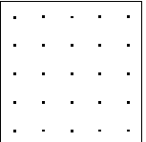
2. Trapezoids have one pair of parallel sides.

always

sometimes

never
3. Parallelograms are quadrilaterals.

always

sometimes

never

4. All rectangles are squares.

always

sometimes

never
5. A rectangle is a parallelogram.

always

sometimes

never
6. A trapezoid can have at least one right angle.

always

sometimes

never

