Quadrilaterals Review Homework Page 1

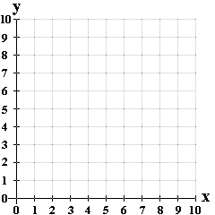

1. Graph the following coordinates:

(4, 9); (9, 9); (7, 6); (6, 6)

Connect the points in order starting at (4, 9).

What shape was created when you connected the points?

How do you know? What is the evidence?



1. Graph the following coordinates:

(2, 2); (8, 8); (9, 7); (3, 1)

Connect the points in order starting at (2, 2).

What shape was created when you connected the points?

How do you know? What is the evidence?

Quadrilaterals Review Homework Page 2



1. Graph the following coordinates:

(5, 10); (8, 7); (5, 4); (2, 7)

Connect the points in order starting at (5, 10).

What shape was created when you connected the points?

How do you know? What is the evidence?



1. Graph the following coordinates:

(1, 7); (4, 10); (4, 6); (1, 3)

Connect the points in order starting at (1, 7)

What shape was created when you connected the points?

How do you know? What is the evidence?